Purpose Statement

The purpose of this project is to develop software for a device that improves the well-being of employees and the ergonomics of office spaces. The project will deliver an indoor mapping system through the use of audio technology.

Specific Tasks.

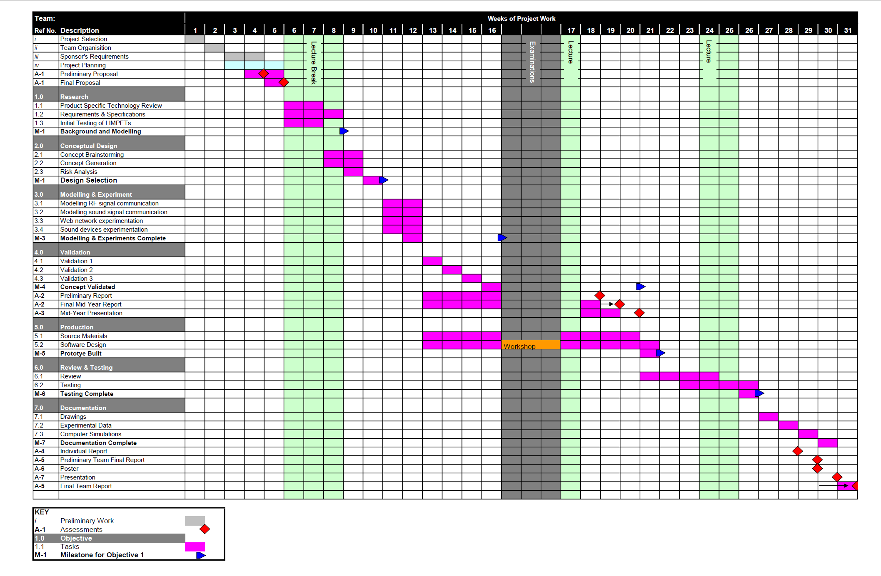The specific task and the timeline of these task is expressed below in figure xx, a Gantt Chart. This chart illustrates the split of subtasks and the potential time required to complete them. With the times it is important to remember that this is not the sole focus of the group members. The expected contact time for the project is only nine hours per week per student and as such some tasks have larger timelines, as they are not the singular focus of the week.

Figure xx

Below there are furter descriptions on the specific modules involved in the project.

Research

The initial research will be focused on the significant technologies involved in the project. Namely these are the sound devices (microphone and speaker), the mesh communications network, the indoor mapping and the actual sound used to measure distance. Each of these sections will be separately researched by group members over a 2-week period. Alongside this research we can also begin developing the requirement and specifications for the final product.

The initial LIMPET technology testing is scheduled at this time as well but will be dependent on the delivery of the prototypes.

Conceptual Design and Modelling

The next phase of the project will involve developing the idea of the final product through brainstorming, and then investigating the specific technologies that will help us to actualize it. The modelling and experimentation will be based around the RF and sound signal communications, the 3D mesh and the sound devices used to propagate and receive the signal.

Validation and Production

The project idea must be validated so that the development can begin. During the process of validation, some light work can be conducted in terms of development and sourcing required parts of the project, as these can take excessive time if shipped. The development will be mainly software design, and the basic structure for this can be set up during the validation process. The designing section is the most important and the longest leg of the project and will eventually result in the finished working prototype.

Testing and Documentation

The prototype is tested and reviewed so that it fulfils the requirements and does not include any errors or bugs. The project will be tested both on software and on the sound signal strength, to ensure it is in fully working order. The documentation will compile information on the final product, which will be important for sponsor and users.

Reports and Presentations.

Interspersed through the year will be various presentations and reports on the project, both individual and group based. These will be started at least two weeks before the due date, to give optimal time to complete it.